Contents

**Author** 1

**Project Topic** 1

**Introduction** 1

**RIP Simulation** 3

Task Introduction and Tools Needed 3

Step 1 3

Step 2 4

Step 3 7

Step 4 8

Step 5 9

Step 6 10

Step 7 11

**Routing Table** 11

**Conclusion** 12

# **Author**

Afari Jesse

P191301

# **Project Topic**

RIP Simulation Using Cisco Packet Tracer

# **Introduction**

Routing Information Protocol

The RIP is a distance vector protocol that distance or hop counts as its primary metric for determining the best forwarding paths. It is a distance vector protocol because it routinely sends its neighboring routers copies of its routing tables to keep them updated.

The routing table contains a list of specific routing destinations. When the router receives a packet of data, it references the routing table to know where to send that data. The routing table may also contain information on how far each destination is from the router. In essence, a routing table is a map for the router.

A routing table does not contain a list of all possible destinations. Rather, it contains a list of destinations that are next in line to the router. Each router contains this list. When a packet is received, it's directed to the next network link as listed in the table, until it reaches its final destination. The routing table contains a list of IP addresses, Gateway addresses, and other information.

RIP defines how routers should share information when moving traffic among an interconnected group of local area networks. It is also characterized as an interior gateway protocol, and is typically used in small to medium-sized networks

RIP operates on the application layer of the OSI model. To configure Routing Information Protocol is fairly simple. Once IP addresses have been assigned to the involved computers and interfaces of routers, we can issue the router RIP command which tells the router to enable RIP followed by the network command which allows users to identify which networks they want to work with. Only the networks directly associated with the router need to be specified.

RIP Timers are also components that helps regulate performance

**Periodic timer**: This is a 25 to 30 seconds timer that updates the neighboring routers with routing tables.

**Invalid timer**: RIP waits 180 seconds to mark a route as invalid and immediately puts it into hold-down

Using RIP comes with a set of advantages with include

1. A feasible configuration
2. Easy to understand protocol
3. It Provides fast convergence
4. Very Simple

There are two version of RIP which are version 1 and version 2

The version 1 does not support authentication whereas the version 2 does.

The version 1 does not carry subnets in its updates but the version two does.

In version 1 routing tables are broadcasted but in version 2 they are multicast.

# **RIP Simulation**

## Task Introduction and Tools Needed

To make this simulation we will be trying to send packets from different machine on different networks to different computers in a local area network.

To do this we first need to install the software to be used with is cisco packet tracer

The Cisco Packet Tracer is a cross-platform visual simulation tool designed by **Cisco** Systems that allows users to create network topologies and imitate modern computer networks. The software allows users to simulate the configuration of **Cisco** routers and switches using a simulated command line interface.

## Step 1

* Set up the network using the components need and connect them using a cable. (4 computers, 2 switches, 2 routers).

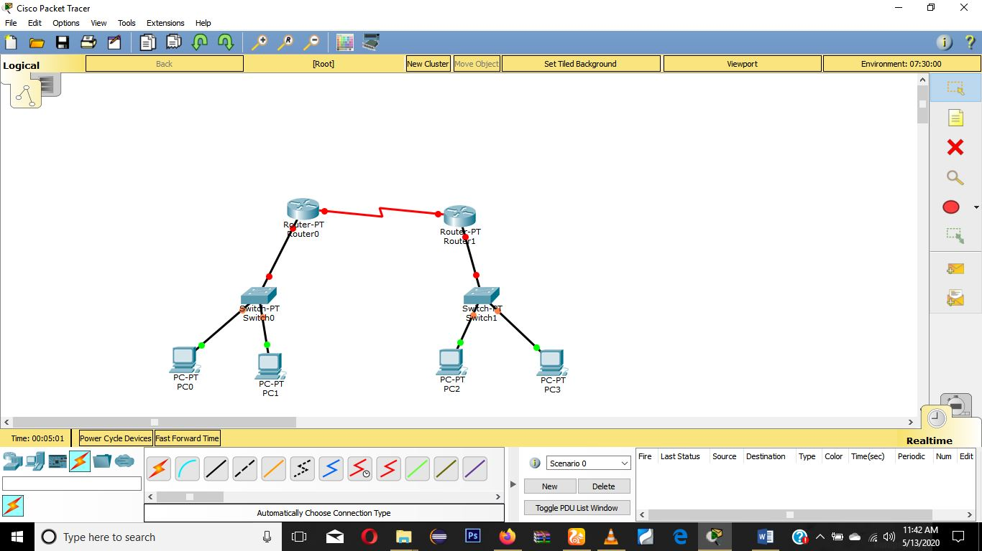

## Step 2

* Once the components have been placed the next thing is to configure the routers. But before that we first have to configure the computers being used. Now we understand the two pairs of computers are on different networks. N1=192.168.1.0 and N2=192.168.2.0. So each router needs to be configured for each network.

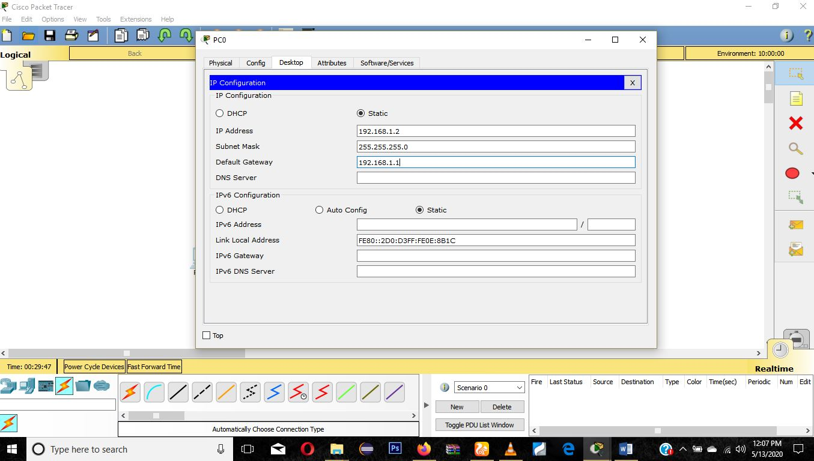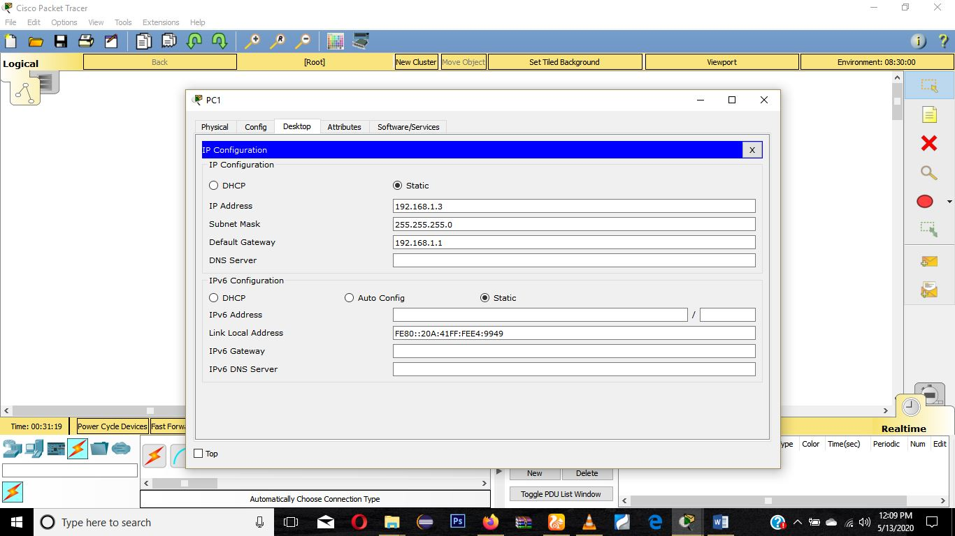

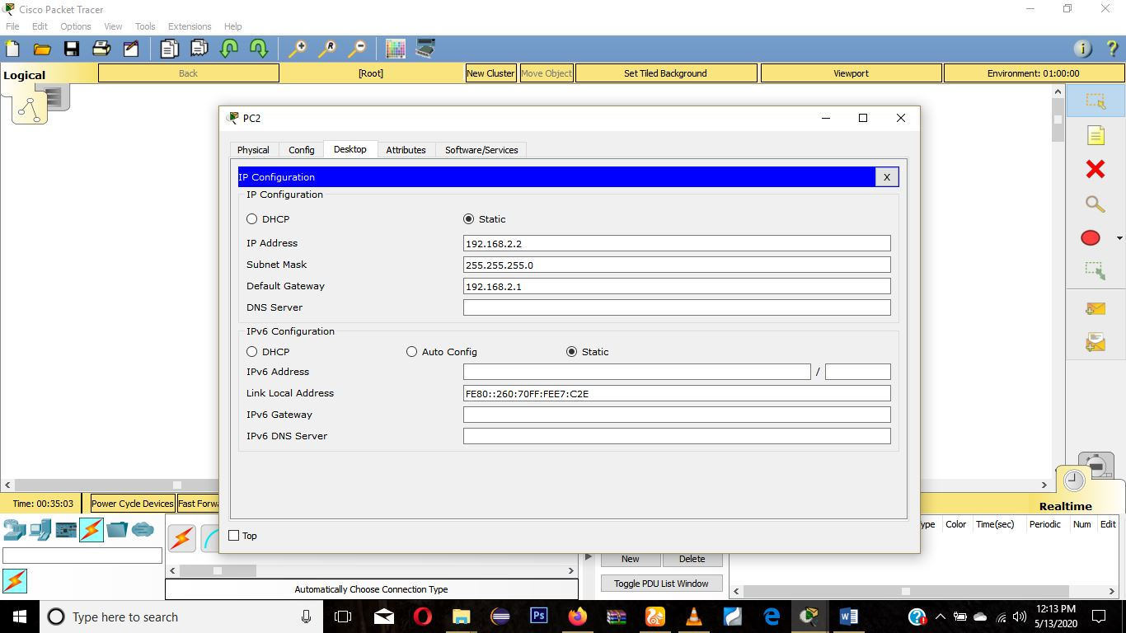

## Step 3

* Upon configuration of computers next is to configure the routers to the networks

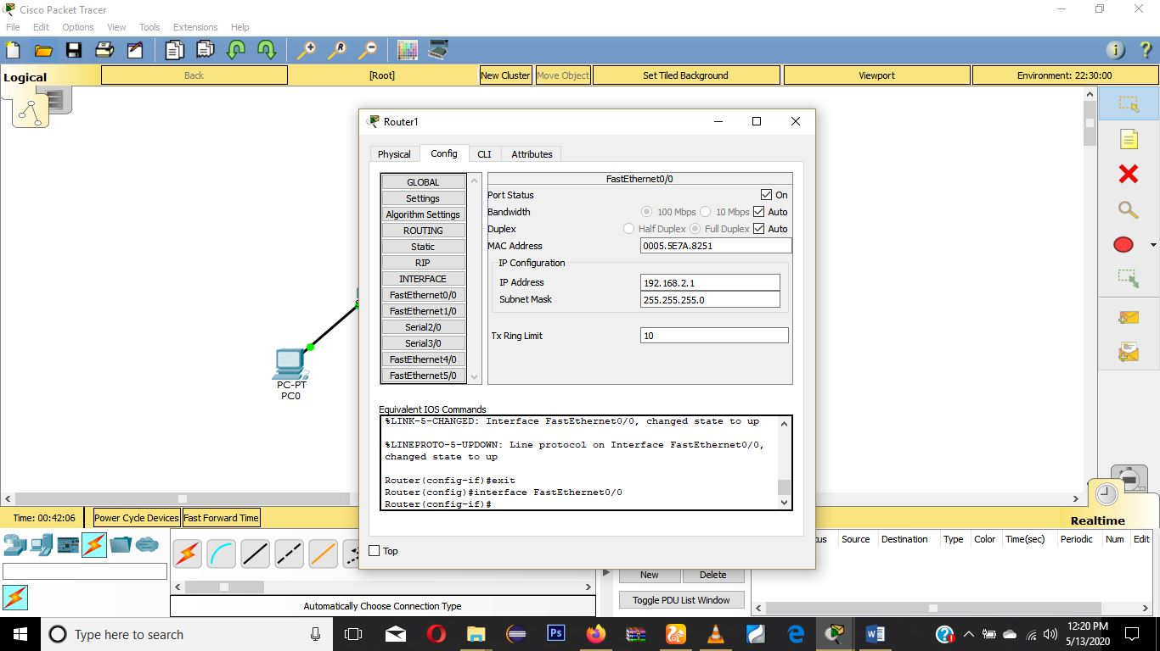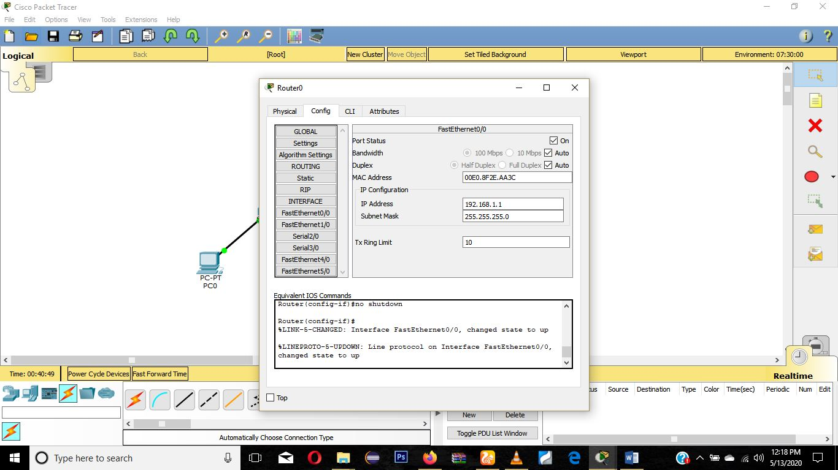

## Step 4

* Next step is to configure the link that exists between the routers. Which will be defined as 10.0.0.0. So first we go to the router to configure its serial port

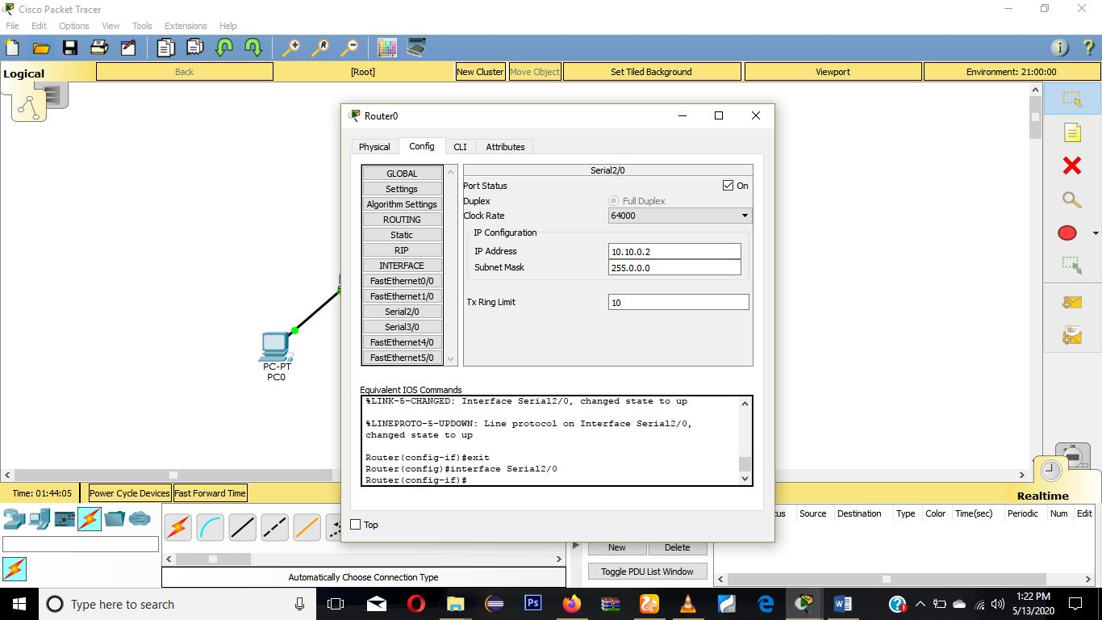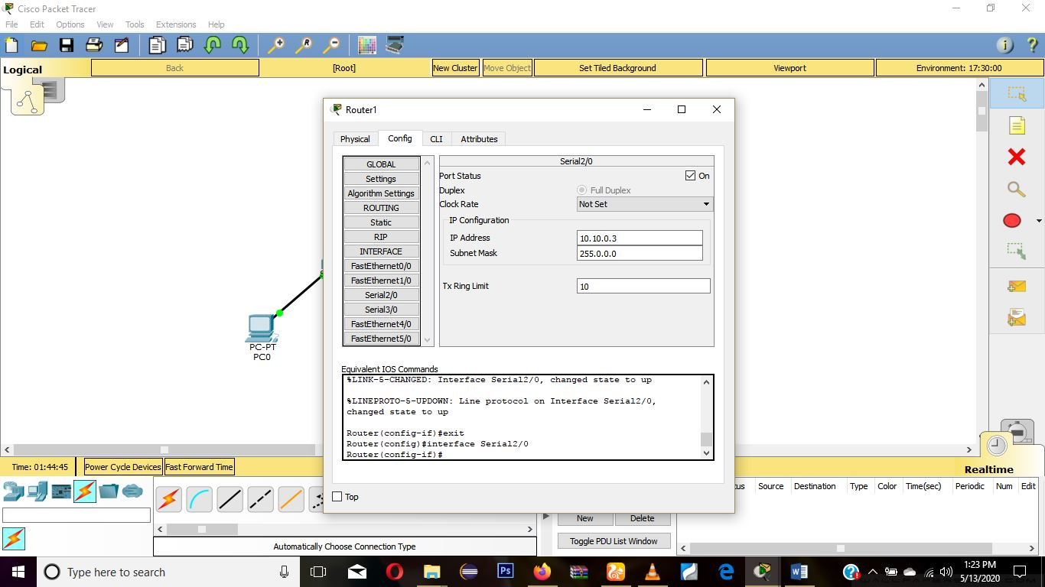

Once that is done we notice all links are up and running properly. Green colored nodes signifies that.

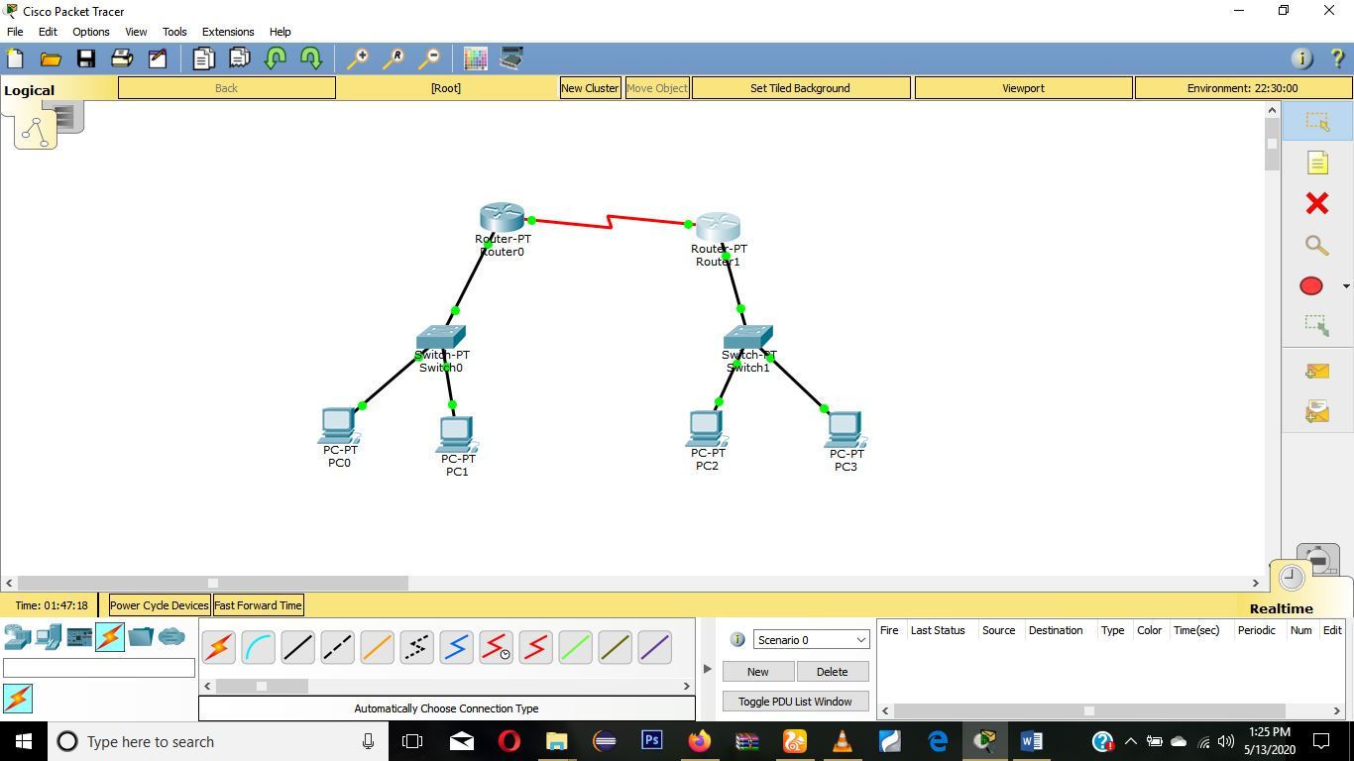

## Step 5

* Next is we try sending packets in the same networks to ensure connection and configurations have been done properly.

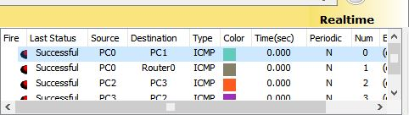

Packets are delivered successfully amount computers on the same network.

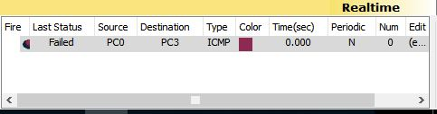

But on different networks it fails

## Step 6

* To send packets from pcs on different networks we need to issue the RIP command and specify which routers we want to work together with. Here what we are doing is telling router 1 about the networks in router 2 and vice versa

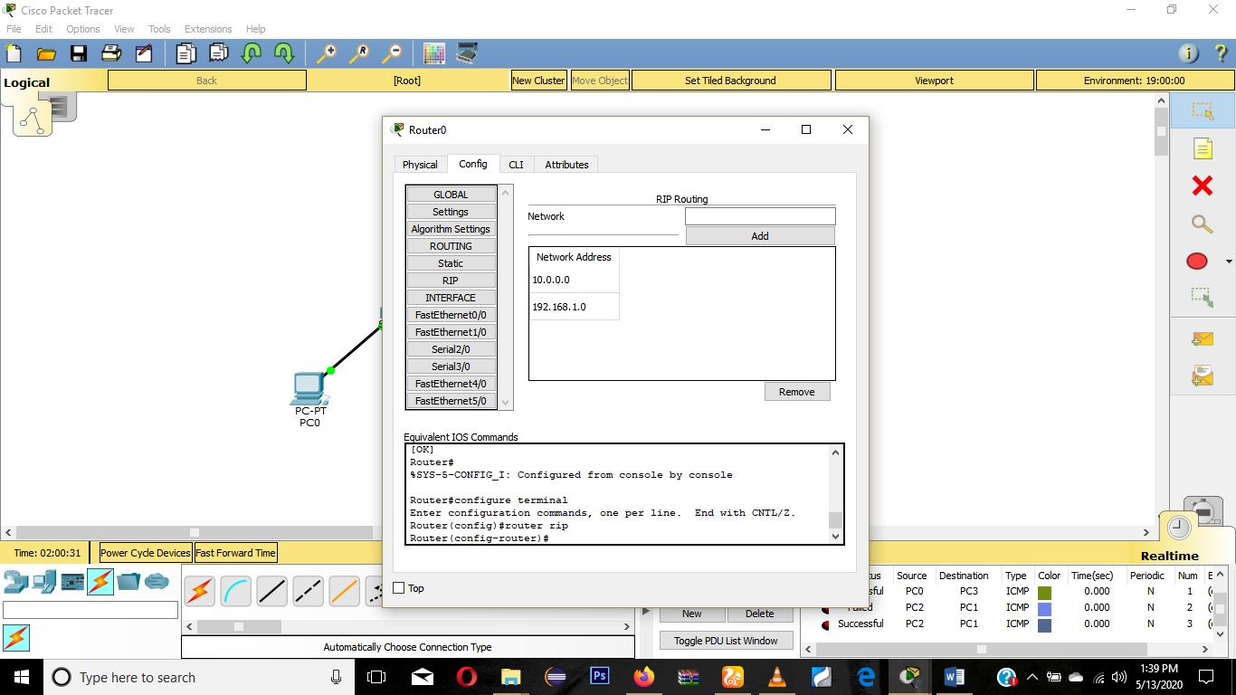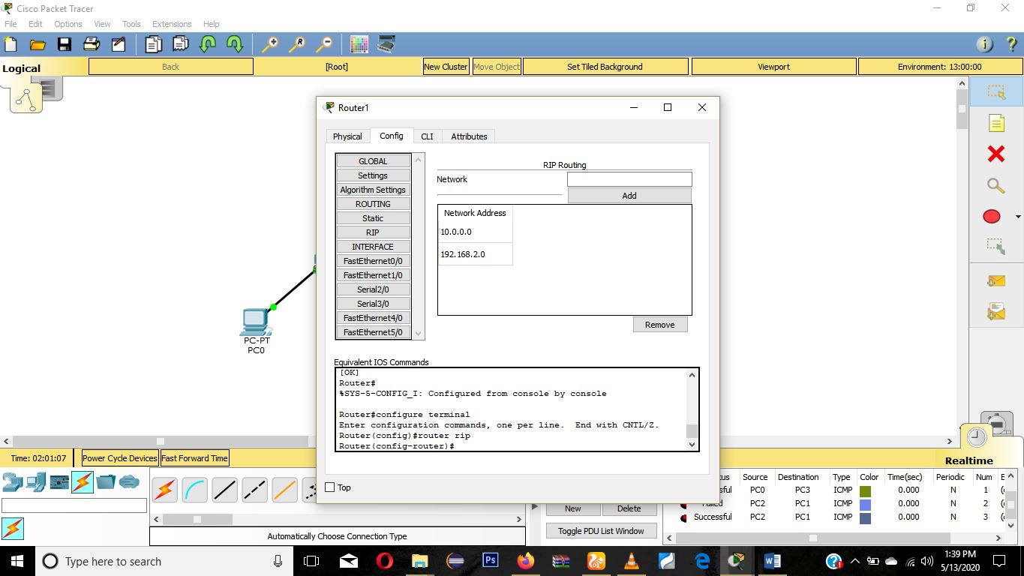

## Step 7

* On completion if we send packet from a computer to another computer. We notice that transfer was successful. This is because neighboring routers have share the necessary information in the routing table.

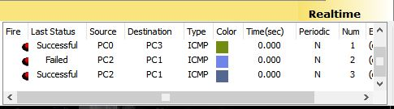

# **Routing Table**

To check the routing table we issue the “show ip route” Command in the command line of the router.

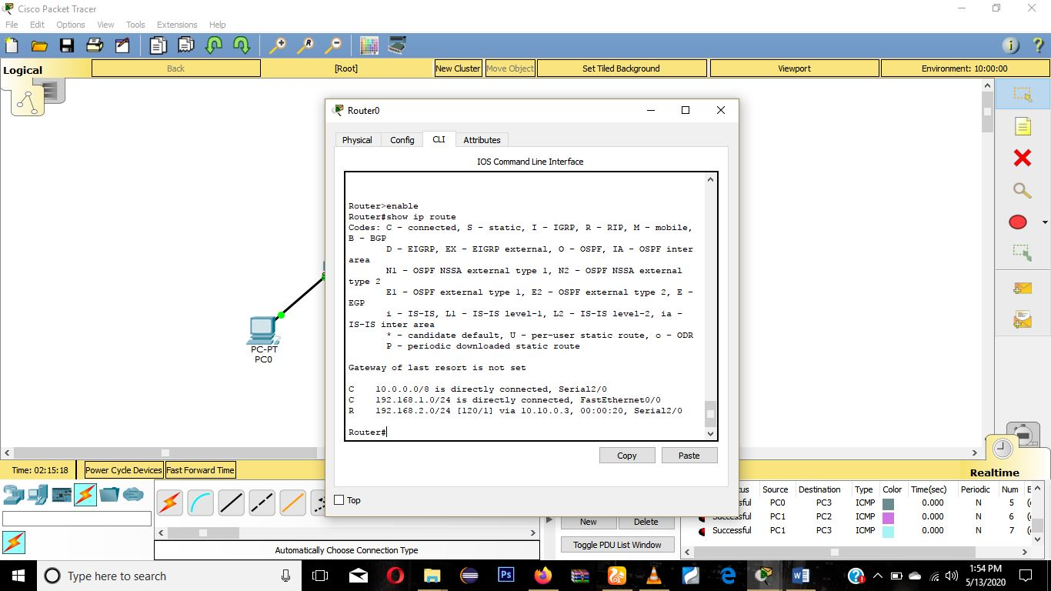

Once routes are updated periodically and packets are delivered successfully we can say simulation has been successful.

# **Conclusion**

RIP defines how routers should share their information when moving packets among an interconnected group of lans. Though is the routing table is sent to a multicast address, reducing network traffic, simple and easy to configure the RIP when there’s a larger network it leads to slow convergence and also constant update of neighboring routers takes its toll on the bandwidth and increases network tracfic. In addition, the closest path may not be the shortest path. This is because RIP does not take various factors into consideration when calculating the shortest path.